Jimmy Vang

9/21/2016

Intro to Java

BMR.java

# Testing Document

The program I made to calculate BMR consisted of two programs. For both programs, I plugged in values for my age (19 yrs), weight (120 lbs), and height (68 in). The calculated results are shown in text and in the images below.

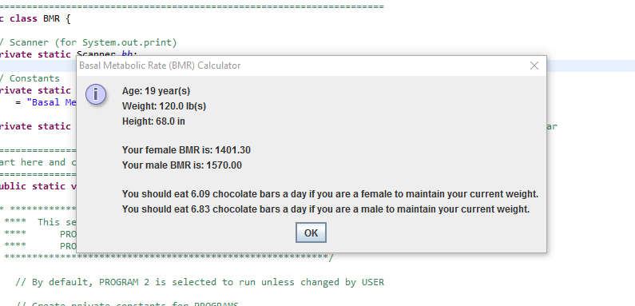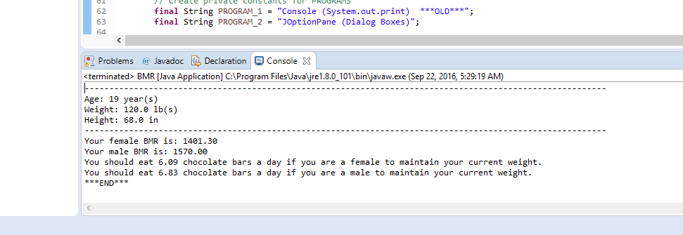 Female BMR was “1401.30”.  
 Male BMR was “1570.00”.  
 Females should eat “6.09” chocolate bars a day.  
 Males should eat “6.83” chocolate bars a day.